Pokhara University

Level: Bachelor | Semester: Spring | Year : 2009
Programme: BE |  | Full Marks: 100
Course: Engineering Mathematics III |  | Pass Marks: 45
 |  | Time : 3hrs.

Candidates are required to give their answers in their own words as far as practicable.
The figures in the margin indicate full marks.

Attempt all the questions.

 | - Define Transpose of a matrix. If A and B are two matrices of order m×p and p×n prove that (AB)^{T} = B^{T}A^{T}.  - Using the properties of determinant, show that  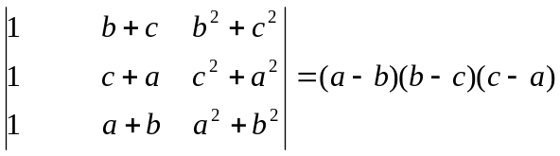 | 8  7
 | - Define rank of the matrix. Find rank of the matrix  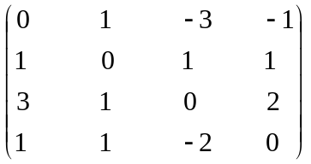  - Define consistence and inconsistence of a system of linear equations. Solve the given system of equations by using Gauss elimination method.  x + y + z = 8  x – 2y + z = 6  3x + 5y – 7z = 14 | 7  8
 | - Define eigen value and eigen vectors of the square matrix. Find eigen value and vectors of the square matrix 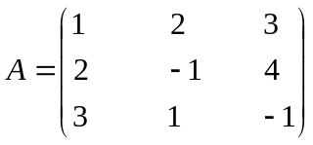  - Prove that the necessary and sufficient condition for the vector function of scalar variable t to have constant direction is 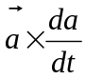. | 7  8
 | - By using Green's theorem evaluate the following integral: 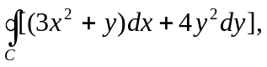C is the boundary of the triangle with vertices (0, 0), (1, 0), (0, 2) in anti-clockwise direction.  - State and prove Gauss divergence theorem.  OR  Evaluate 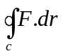where 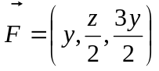, C is the circle of x² + y² + z² = 6z, z = x + 3. | 7  8
 | - State and prove D’Alemberts Ratio test.  - Find the interval of convergence of an infinite series 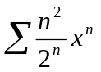.  OR  Find expansion of 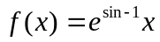as far as the term in x⁴, by using Maclaurin expansion. | 8  7
 | - Define periodic function. Find the fourier series representation of the periodic function 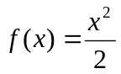for 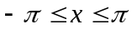 and then show that 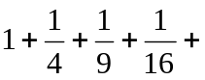.......... = 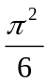 and 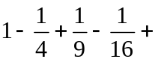........ = 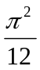.  - Find Fourier sine as well as cosine series representation of the half range function 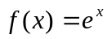 for 0 < x < L. | 8  7
 | - Evaluate using Cramers rule: x + 2y = 5 and x – y = 2.  - Check exactness condition under the integral sign 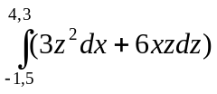and evaluate.  - Find the directional derivative of the scalar valued function 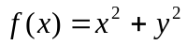, at (1, 2) in the direction 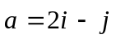.  - Test convergence or divergence of the infinite series 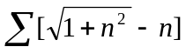  - Check exactness condition of the value under the integral sign 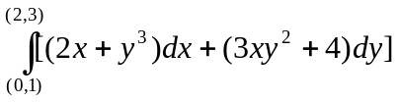 and then evaluate the integral. | 2  2  2  2  2

